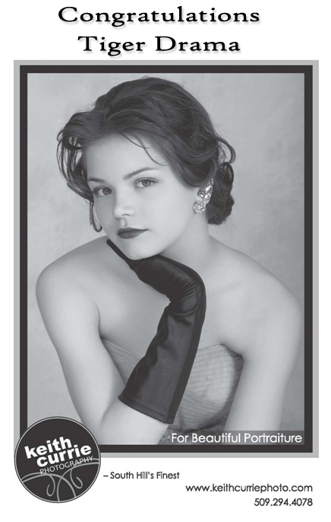

|  |
| --- |
| PLAYBILL TITLE  LEWIS & CLARK TIGER DRAMA |

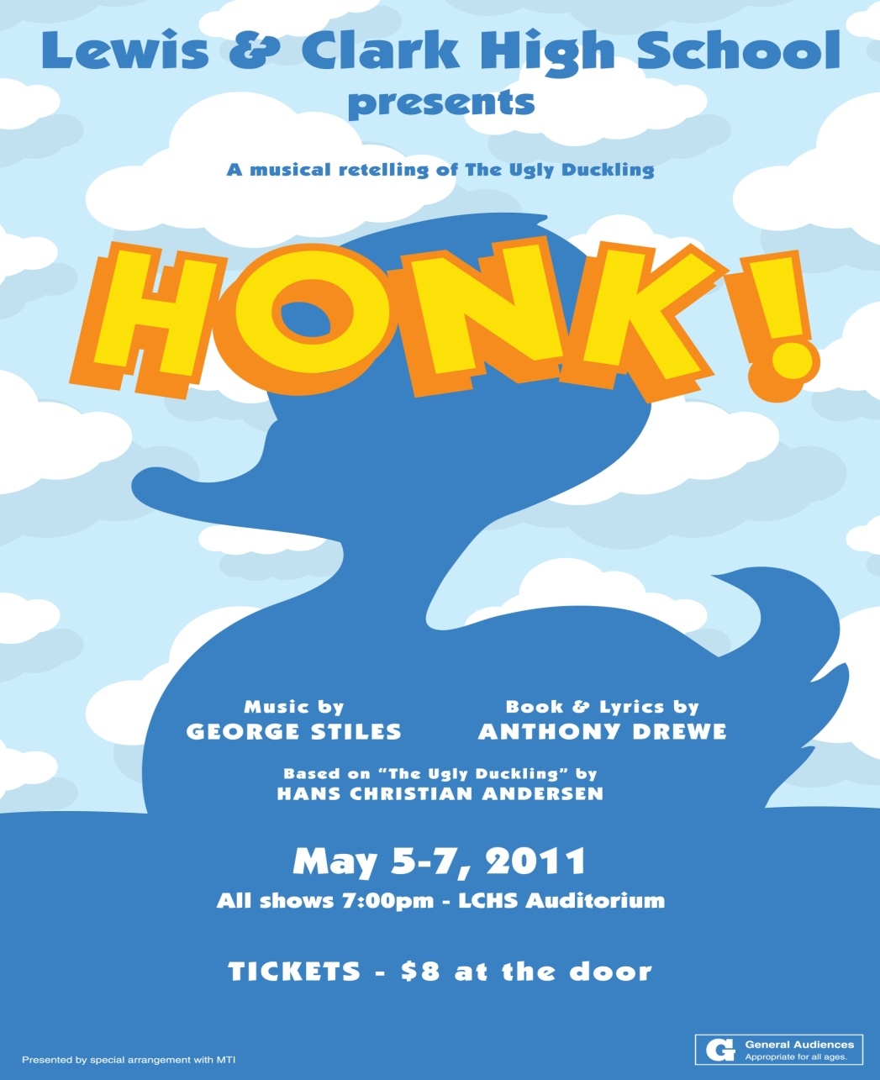

|  |
| --- |
| **WWW.TIGERDRAMA.COM** |





LEWIS & CLARK

TIGER DRAMA



Greg Pschirrer, Director and Choreographer

|  |  |
| --- | --- |
| DANNY PALOMBA | EMILY PUCKETT |
|  |  |
| JON O’GRADY | KEYONNA KNIGHT |
|  |  |

By George Stiles and Anthony Drewe

*with*

|  |  |  |
| --- | --- | --- |
| Maddie Ballou | Hannah Barz | Laura Chamberlain |
| Kelsey Christensen | Liz Connelly | Shadey Dickinson |
| Maddy Green | Asya Hampton | Kehly Hedrick |
| Hannah Hudson | Kate Janzen | Benjamin Marks |
| Katie May | Jessica Newell | Mary Ormsby |
| Phoibe Purcell | Madison Rasmussen | Nora Swoboda |
| Jesse Ward | **Kaitlin Webster** | Andrew Wildman |
| Camille Wintz | Taylor Wright |  |

|  |  |  |
| --- | --- | --- |
| *Lighting Design* | *Poster Design* | *Costumer* |
| Kevin Shields | Geoff Elliot | Lisa Caryl |
|  |  |  |
| *Program Design* | *Sound Design/Headshots* | *Scene Design/Construction* |
| Theresa Meyer | Scott Martinez | Stagecraft Class |
|  |  |  |

Produced by special arrangement with Musical Theatre International.

*HONK! Is presented in its entirety with no intermission.*



Em, we are so proud of how much

you have grown as a singer and actress!

Rock the house!

-Love, Mom, Ralph, and Joey

|  |  |  |  |  |  |  |  |  |  |  |  |  |  |  |  |  |  |  |  |  |
| --- | --- | --- | --- | --- | --- | --- | --- | --- | --- | --- | --- | --- | --- | --- | --- | --- | --- | --- | --- | --- |
| **Heart to Heart Counseling**  (509) 747-7147  1503 W. 7th Ave., Spokane, WA 99204  ~8 counselors ~  A safe & confidential environment  Specialties include:   |  |  |  |  | | --- | --- | --- | --- | | Individual | Groups | Couples |  | | Teens | Marriage & Family | Children |  | | Addiction | Co-Dependency | Anxiety |  | | Stress | Crisis Intervention | Grief |  | | Depression | Mental Illness | PTSD |  |   Most insurance accepted  Evening and weekend appointments available  [www.heartheart.org](http://www.heartheart.org) |
| ***Sandalwood***  ***Counseling & Coaching***  1503 W. 7th Ave., Spokane, WA 99204  509 747 7149  Announcing Life Coaching Groups for Teens  Whether students are struggling with how to improve and maintain grades, planning for life after graduation, developing life skills in general or dealing with a pregnancy, a coaching group can help. In a coaching group young people interact with others of their age group who are handling the same or similar life events, while a certified life coach guides them in creating and achieving their goals.   * Strategies for achieving * Maintaining good grades * Real Life After Graduation * Life Skills * Teen Parents   Individual and Group Coaching |



Congratulations to all theater students, staff and volunteers on a wonderful 2010-11 season!

Maplewood Software develops products, both products we sell, products other companies sell, and products that are not intended to be sold. We offer everything needed for a custom project. We can enhance your staff with our experts. We can be your team or we can help your team with Project Management or Database development. We really enjoy adding the functionality of our products to a product or service you may offer or already own.

Maplewood Software

[www.maplewoodsoftware.com](http://www.maplewoodsoftware.com)

1-877-229-5230

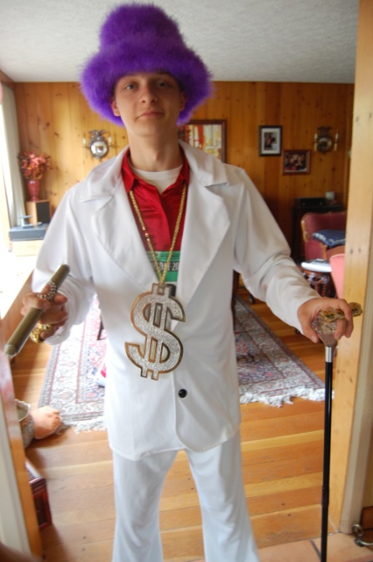

Since your Freshman theatrical “debut” in *Miss Saigon* we’ve delighted in watching you go on to perform in *Little Shop of Horrors, Chicago, Epic Proportions, Seussical, Guys & Dolls,* *Urinetown*, *The Four Princes, Twelfth Night, Hairspray*, and now *Honk*!., your final high school performance. As you say goodbye to the amazing Musical Theatre program at LC and head for college in Seattle, we can’t wait to see how much more enjoyment and laughter you will bring to all the audiences in your future! We love you, Jon!

Mom, Dad, Caroline, Larry, Loretta & your devoted fan club!

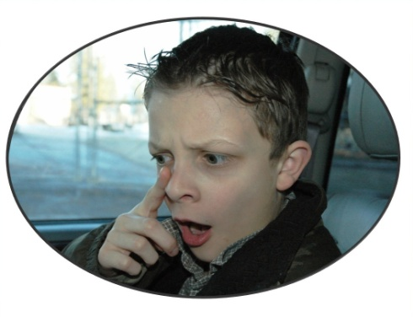

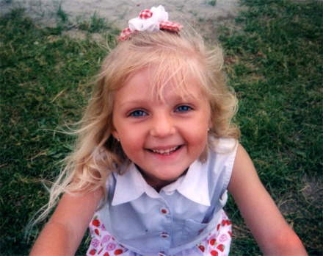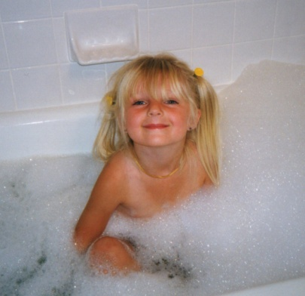

Jessica,

We are all so proud of you and your many talents. We have enjoyed all of your performances and will continue to follow and support your theater career! Thank you for bringing such joy to our lives.

Love,

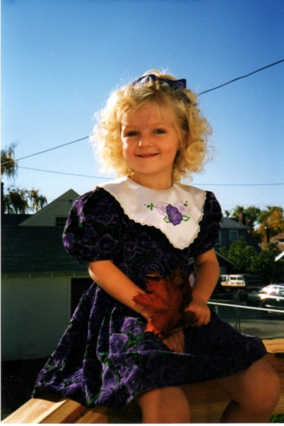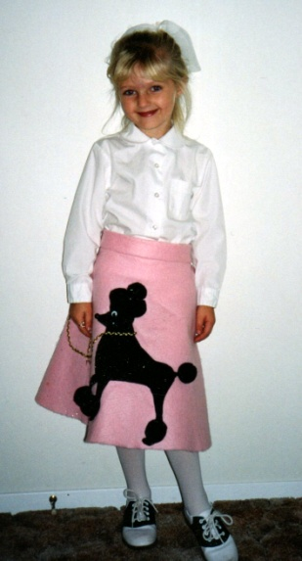Mom, Joey, James, Ashley, Grandma Arlene, Chris, Cole & Brooke

|  |
| --- |
| **[Instant Sign Factory - We Make You Look Good. Instant Sign Factory manufactures vinyl banners, decals, rigid signs, window lettering, vehicle graphics, window graphics, vehicle magnetics, event banners, sponsor signs. Authorized supplier of Gemini Dimensional Lettering.](http://www.instantsignfactory.com/)**  **Instant Sign Factory** manufactures vinyl banners, decals, rigid signs, window lettering, vehicle graphics, window graphics, vehicle magnetics, event banners, sponsor signs, printed and imprinted promotional products.  **INSTANT SIGN FACTORY**  721 W 2nd Ave  Spokane, WA 99201  Phone: 509-456-3333  [www.instantsignfactory.com](http://www.instantsignfactory.com) |

**WHO’S WHO IN THE CAST**

|  |  |
| --- | --- |
| **C:\Documents and Settings\TheresaM\Desktop\honk headshots\New Folder\DSC_2761.jpg** | **Andrew Wildman** (Class of 2012) appeared in LC’s *Hairspray, Urinetown,* and Stage Managed *12th Night*. He is involved in Spokane Area Children’s Chorus, Boy Scout troop 343, and many clubs at LC, including Debate, Chess, and Drama club. He dedicates his performance to his family and friends. |
|  |  |
| **C:\Documents and Settings\TheresaM\Desktop\honk headshots\New Folder\DSC_2751.jpg** | **Camille Wintz** (Class of 2011) is in both Advanced Drama and Musical Theatre this year and appeared in LC’s production of *Check, Please and Other Unusual Situations.* |
|  |  |
| **C:\Documents and Settings\TheresaM\Desktop\honk headshots\New Folder\DSC_2772.jpg** | **Taylor Wright** (Class of 2013)made his debut in LC’s *Guys and Dolls* and went on to play Professor Quirrel in *A Very Potter Musical*. His interests include Skiing, guitar, singing, skiing, and skiing. He would like to dedicate this performance to his friends and family who have always been so supportive of him! |
|  |  |

|  |
| --- |
| **Stay updated on everything that is going on at LC!**  Untitled-1 copy.gif  Visit  [**www.lctigers.com**](http://www.lctigers.com) |

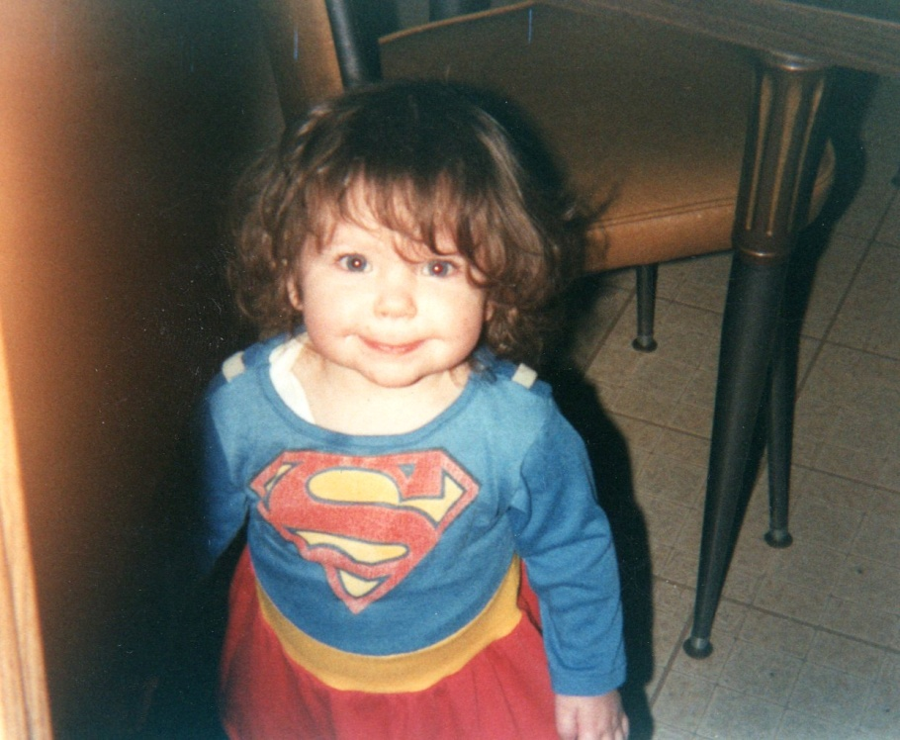

To Shadey,

My beautiful and talented daughter, may all your dreams come true.

Love, Dad

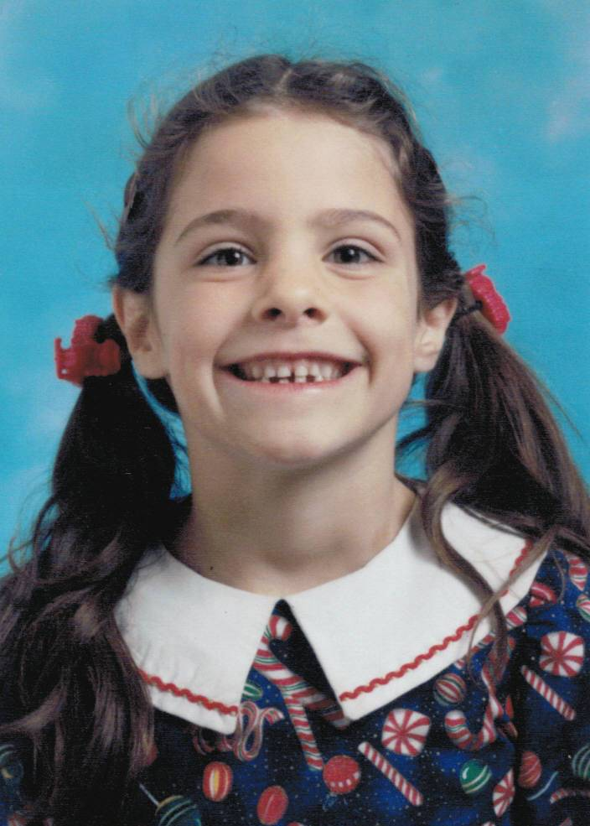

Kate ... you have been adding joy and beauty to the world since the day you were born.  We love your talented, creative spirit!

Congratulations!

Dad, Mom, Ellie and Hazel

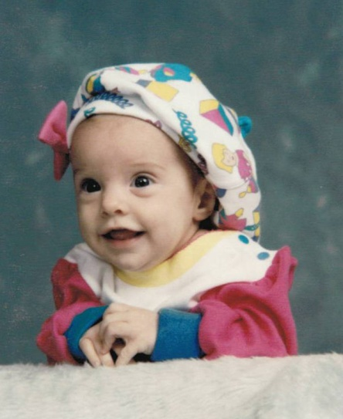

**WHO’S WHO IN THE CAST**

|  |  |
| --- | --- |
| **C:\Documents and Settings\TheresaM\Desktop\honk headshots\New Folder\DSC_2617.jpg** | **Madison Rasmussen** (Class of 2013) is appearing in her 5th show at LC. Madison is a member of LC’s chamber choir, and is taking voice lessons with Mrs. Mosback. She has done theater since she was 8, and is ecstatic to be participating in *Honk!* She would like to dedicate this performance to all of her wonderful friends, especially her dear friend Jennifer Paige. |
|  |  |
| **C:\Documents and Settings\TheresaM\Desktop\honk headshots\New Folder\DSC_2731.jpg** | **Nora Swoboda** (Class of 2013) began her ballet training at Ballet Arts Academy at the age of five.  This will be Nora's second performance with LC after previously appearing in *Hairspray* (Tammy). She dedicates her performance to her best friend, Hannah Hudson, who has always supported her. |
|  |  |
| **C:\Documents and Settings\TheresaM\Desktop\honk headshots\New Folder\DSC_2624.jpg** | **Jesse Ward** (Class of 2012) is thrilled to appear in his eighth LC production. He has performed with the Spokane Civic Theatre, Spokane Children’s Theatre, Spokane Area Children’s Chorus and the Spokane Opera. Favorite roles include *Guys and Dolls* (Sky Masterson), *Urinetown* (Hot Blades Harry), and *Twelfth Night* (Toby Belch). He was awarded top honors at both the regional and statewide Thespian Festivals. |
|  |  |
| **C:\Documents and Settings\TheresaM\Desktop\honk headshots\New Folder\DSC_2608.jpg** | **Kaitlin Webster (Class of 2011)** hopes to major in Music education next year. Her appearances include *Hairspray* (Amber), *Urinetown* (Ms. Millennium), *Jungle Book* (King Louie), *Aladdin* (Aladdin), *The Legend of Pocahontas* (Amy), *Peter Pan* (Michael). She has been a member of the Spokane Area Children's Chorus for eleven years. "Thanks everyone for supporting me and my dreams! You all rock and I'm gonna miss you!” |

**WHO’S WHO IN THE CAST**

|  |  |
| --- | --- |
| **C:\Documents and Settings\TheresaM\Desktop\honk headshots\New Folder\DSC_2693.jpg** | **Mary Ormsby** (Class of 2011) has appeared in several shows for Spokane Children’s Theatre, Spokane Civic Theatre, and is excited to be appearing in her fourth show for LC. Some of her favorite roles include *The Snow Queen* (Robber Girl), and *Far Away* (Young Joan). She dedicates this performance to her mom, who is the one who tends to take her to all her rehearsals, and her friends for always being there for her. |
|  |  |
| **C:\Documents and Settings\TheresaM\Desktop\honk headshots\New Folder\DSC_2677.jpg** | **Danny Palomba** (Class of 2013) has been playing piano for 6 years and guitar for three years. LC appearances include *Urinetown* (Officer Barrel) and *12th Night* (Sebastian). He is happy to be performing with his friends and would like to say goodbye to the Seniors that have taught him so much (he will miss them). He dedicates this performance to his family and especially his friends who have taught him to be a better actor and person. |
|  |  |
| **C:\Documents and Settings\TheresaM\Desktop\honk headshots\New Folder\DSC_2683.jpg** | **Emily Rose Puckett** (Class of 2011) has been in three LC productions: *Guys & Dolls* (Mission Doll), *A Very Potter Musical* (Crabbe), and *Urinetown* (Penelope Pennywise). She also has been in Box ‘n’ Hat at Civic Theatre, as well as *Heidi* with Children’s Theatre. Emily takes voice lessons from Dennis Craig, and loves playing and writing music in her free time. She dedicates her performance as Ida to all of her loved ones. |
|  |  |
| **C:\Documents and Settings\TheresaM\Desktop\honk headshots\New Folder\DSC_2680.jpg** | **Phoibe Purcell** (Class of 2013) is appearing in her third LC production after *A Very Potter Musical* and *12th Night*.  She began acting through workshops at Spokane Civic Theatre and hopes to continue. She dedicates this performance to her wonderful family, friends, and fellow performers. |

|  |
| --- |
| **Camille Wintz**  To our most lovely Jay Bird.  “No bird soars too high if he soars with his own wings.”  - William Blake  Your wings have grown strong in these past 18 years; we anticipate mighty tales of your many beautiful journeys.  Love,  Mom, Dad, and Colin  C:\Users\lleblanc\Desktop\lynda\1-6-2011\IMG_0654.JPG |
| Danny,  C:\Documents and Settings\TheresaM\Local Settings\Temporary Internet Files\Content.Word\Melina%20Gym-Christ.%2007-08[1].jpgGrandmas are allowed to be proud. So, Proud? Of Course! Surprised? No! I enjoy so much about you Danny. Your piano and guitar playing, your singing and even your silliness. But not the least is your total dedication to the roles you take on. It is such a joy to watch the shows. Congratulations on "Honk"! Can't wait to see it. Break a leg! Grandma |

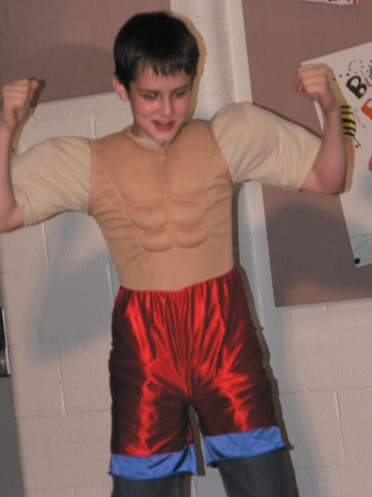

Congratulations, Danny Boy!

We are very proud of you.

Love,

Dad, Mom & Melina

|  |
| --- |
| **Lewis and Clark High School**  **is proud to participate in**  **The 5th Avenue High School Awards**  **Honoring Outstanding Achievement in**  **High School Musical Theatre.**  ***Hairspray 2011***  ***Guys and Dolls 2010***  ***Chicago 2009***  ***Miss Saigon 2008***  ***Grease 2007***  **www.5thavenue.org/education** |

|  |  |  |  |  |  |  |  |  |  |  |  |  |
| --- | --- | --- | --- | --- | --- | --- | --- | --- | --- | --- | --- | --- |
| **Special thanks**  **to the following for their**  **support of this production:**     |  |  | | --- | --- | | **Pam Pschirrer** | **Spokane Children’s Theatre** | | **Judy & Michael McGiveny** | **Lisa White** | | **Nancy Janzen** | **LCHS Business Office** | | **Alicia’s on 8th** | **ACC Sportswear** | | **Barb Chamberlain** | **Jim & Debbie Swoboda** | | **Sue Connelly** | **Theresa Meyer** | |

**What’s the**

**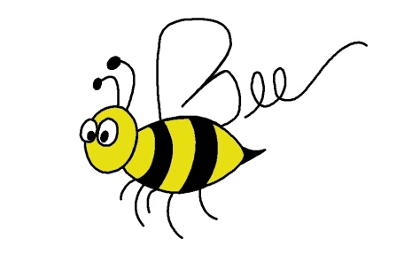Buzz?...............**

**Spokane Civic Theatre’s production of “The 25th Annual Putnam County Spelling Bee” is going to National Competition in Rochester, NY - June 20-26, 2011. Spokane Civic Theatre has won more awards than any other Community theatre in the nation. Would you help send the cast/crew to Rochester by participating in the following events?**

**Tuesday, May 31st – 7:00 @ Lewis & Clark High School**

Audience Dress Rehearsal of   
“The 25th Annual Putnam County Spelling Bee”

**Wednesday, June 1st – 7:00 @ Lewis & Clark High School**

Audience Dress Rehearsal of  
“The 25th Annual Putnam County Spelling Bee”

***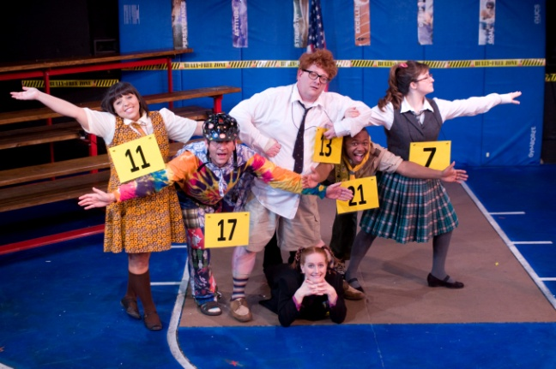***

|  |  |  |  |  |  |  |  |  |  |
| --- | --- | --- | --- | --- | --- | --- | --- | --- | --- |
| **Revisit our past seasons at** [**www.tigerdrama.com**](http://www.tigerdrama.com)   |  |  |  | | --- | --- | --- | | Untitled-1 copy.jpg | 12th | C:\Documents and Settings\TheresaM\Desktop\poster.jpg | | pandas | guys and dolls | Suessical | | Epic | Chicago | Saigon | |

****

**Honk! Songs and scenes**

Scene 1: "A Poultry Tale"

"The Joy of Motherhood"

"Different"

"Look At Him"

"Different"

Scene 2: "Play With Your Food"

Scene 3: "Every Tear a Mother Cries"

Scene 4: "Wild Goose Chase"

Scene 5: "The Joy of Motherhood Reprise"

Scene 6: "Warts and All"

Scene 7: "The Blizzard"

Scene 8: "Look At Him Reprise"

"Warts and All"

**WHO’S WHO IN THE CAST**

|  |  |
| --- | --- |
| **C:\Documents and Settings\TheresaM\Desktop\honk headshots\New Folder\DSC_2661.jpg** | **Benjamin Marks** (Class of 2011) previously stage managed *Hairspray* for LC, but is ecstatic to be making his first ever appearance on stage. Ben plans on studying mathematics at Eastern Washington University in the fall, and he dedicates his performance to his loving family who has encouraged him to always follow his dreams. |
|  |  |
| **C:\Documents and Settings\TheresaM\Desktop\honk headshots\New Folder\DSC_2696.jpg** | **Katie May** (Class of 2011) appeared in LC’s *A Very Potter Musical* and *Urinetown*. She has participated in Musical Theatre Class for the last two years, a memorable experience that she cherishes. She has narrowed her college choices down to Western, Gonzaga, and Seattle U, so far planning to minor in Music. Katie thanks her friends, teachers, and family for all of their love and support and dedicates this performance to her parents. |
|  |  |
| **C:\Documents and Settings\TheresaM\Desktop\honk headshots\New Folder\DSC_2631.jpg** | **Jessica Newell** (Class of 2011) is thrilled to be a part of the *Honk!* gaggle! You might have spotted her performances in *12th Night* (Olivia) and *Hairspray* (Prudy Pingleton). After graduation, Jessica will take flight to Stagedoor Manor Summer Camp in New York and then settle down in Seattle and begin her adventures at college. She dedicates her performance to her big brother Joey. Thanks for the love and support bro. |
|  |  |
| **C:\Documents and Settings\TheresaM\Desktop\honk headshots\New Folder\DSC_2646.jpg** | **Jon O’Grady** (Class of 2011) has been an active member of LC Drama since his freshman year, performing in *Miss Saigon*, *Chicago*, *Guys and Dolls*, *Urinetown* (Officer Lockstock), *12th Night* (Malvolio), and *Hairspray* (Corny Collins). He dedicates this performance to his family and loved ones, a group of people who work harder and deal with more stress than any human beings should have to. |

**WHO’S WHO IN THE CAST**

|  |  |
| --- | --- |
| **C:\Documents and Settings\TheresaM\Desktop\honk headshots\New Folder\DSC_2759.jpg** | **Kehly Hedrick** (Class of 2012) is excited to be in her third production at LC. She has previously been seen in *Urinetown*, as well as *Check Please and Other Unusual Situations* (Vaudeville Dancer), and worked crew for *Hairspray*. She would like to thank her family, friends, especially Laura Chamberlain, and the drama department for encouraging her and helping her along the way. |
|  |  |
| **C:\Documents and Settings\TheresaM\Desktop\honk headshots\New Folder\DSC_2753.jpg** | **Hannah Hudson** (Class of 2013) has previously been in the ensemble of both *Guys and Dolls* and *Urinetown*. She also played an Attendant in *Twelfth Night* and is in her third semester of the Musical Theatre class. She is involved in Track, and is participating in her second year of Varsity. She dedicates her performance to her brother Aaron, who is in the war zone, and to her best friend Zola, for being her "Other Half." |
|  |  |
| **C:\Documents and Settings\TheresaM\Desktop\honk headshots\New Folder\DSC_2711.jpg** | **Kate Janzen** (Class of 2011) started her theatrical career in elementary school with Missoula Children's Theater and has subsequently appeared in LC's *Seussical*, *Urinetown*, and *12th Night*. Kate is a Running Start Student at SFCC and hopes to attend Seattle Pacific University next year. She wants to thank her mom, dad, sister and dog for all of their support in her theater endeavors. |
|  |  |
| **C:\Documents and Settings\TheresaM\Desktop\honk headshots\New Folder\DSC_2699.jpg** | **Keyonna Knight** (Class of 2013) appeared in LC’s *Hairspray* (Motormouth Maybell) and *Revenge of the Space Pandas* (Bonnie) and *The Buddy Holly Story* (Female Apollo Singer) at Spokane Civic Theatre. Last summer she played Little Inez in CDA Summer Theatre’s production of *Hairspray*. She dedicates this performance to her grandparents, uncles, Charlotte and Dennis, and her loving mother for everything they do! |

**The Story**

It is Spring, and Drake thinks about life on the farm ("Poultry Tale"). As he attempts to sneak away, Ida scolds him for neglecting their eggs that are about to hatch. Drake believes one huge egg is a turkey's egg, but Ida is doubtful. Ida expresses "The Joy of Motherhood" and is joined by her friend MauaSreen, when all of the "normal" eggs hatch. Drake takes the ducklings to learn to swim, leaving Ida to wait for the fifth egg to hatch ("Different" pre-reprise). It finally hatches to reveal Ugly. Ida is initially shocked but is overjoyed that the new arrival is not a turkey. As she teaches him to swim, she notices his amazing talent ("Hold Your Head Up High").

When Drake and the ducklings return, they are aghast at Ugly's appearance and, along with everyone else, make fun of him, while the Cat admires what a great meal he would be ("Look At Him"). As Ugly tries and fails to "quack," he realizes he's just "Different". The Cat offers to be Ugly's friend and to treat him to lunch, which he happily accepts. Ugly tries to get Ida's permission, but she is too busy. After Ugly leaves with the Cat, Ida realizes Ugly is missing. Everyone splits up to look for him.

In her lair, the Cat is preparing to eat Ugly, who is unaware of the danger ("Play With Your Food"). Just as the Cat is about to strike, the children playing outside send a ball flying through the window, hitting the Cat. Ugly thinks he is hiding and goes to find a hiding place of his own, but ends up getting lost. Back at the duckyard, no one can find Ugly, but Ida refuses to believe he is dead. Jay Bird interrupts and begins to interview Ida for "America's Most Feathered". Ida laments about what it's like to lose one of your children ("Every Tear a Mother Cries").

Meanwhile, Ugly comes across two military geese, Greylag and Dot, and begs for their help. They and their "squadron" of geese decide to go on a reconnaissance mission to find Ugly's home ("Wild Goose Chase"). However, there is a shoot going on in the marsh, so the Cat sneaks in and offers to help out by telling them when the shoot is over, hoping that they will leave him alone with Ugly. Greylag sees through the Cat's plan and takes him along. The Geese and the Cat head off to the shoot, which is still going on, and get

shot down. Ugly, who didn't go on the mission with them, realizes that the Cat is evil and had lied.

Back at the farmyard, Drake is forced into some responsibility, and, now that the ducklings are almost a year old, they are beginning to give Drake a hard time as teenagers. Meanwhile, Ugly finds Penny, a swan, caught in some fishing line and untangles her. Penny, knowing Ugly is a swan, invites him to migrate with her, but Ugly insists that he can't. Just then, a Bullfrog comes hopping by. Noticing his bad mood, he tells Ugly about how "ugliness" is just a matter of taste and that someone out there will always love you ("Warts and All"). The song cheers Ugly up, and the bullfrog leaves. Suddenly, a net drops on Ugly's head. A farmer has caught him for his family's Sunday roast. When the Farmer goes to get his knife, the Cat sneaks back onstage and offers a deal; he will lead Ugly back to the farm, but Ugly has to promise to be the Cat's lunch. Ugly agrees, and both of them head back to the farmyard.

On the way, the two get caught in a blizzard and freeze ("The Blizzard"). Ida unfortunately has gotten caught in it as well. Ida notices them and believes Ugly is dead. Penny and her family come to Ida and tell her to cry, that her tears of hope will save Ugly. Soon Ugly wakes up and realizes he is not a duck, but a swan, then reunites with his mother ("Transformation"). Penny recognizes that Ugly is the one who saved her earlier and the two confess their love to each other. The swans invite Ugly to come learn their ways. Although Ugly wants to stay with Ida, she insists that he go with the swans. As they fly off, Ida sings of how Ugly was different, but Ugly suddenly reappears with Penny, as they have decided to stay with Ida. Just before they leave, Ugly frees the Cat, who has remained frozen this entire time. As the Cat notices Ugly is not a duck but a swan, she goes insane before running away in defeat.

Ugly, Penny and Ida return to the lake; everyone loves Ugly now that he's a swan. They ask for his forgiveness for making fun of him ("Look At Him" Reprise). Ugly happily accepts their apology and introduces Penny. Grace decides to relinquish the Red Band, now the Cygnet Ring, to Ugly, dubbing him "the finest bird on the lake".

**WHO’S WHO IN THE CAST**

|  |  |
| --- | --- |
| **C:\Documents and Settings\TheresaM\Desktop\honk headshots\New Folder\DSC_2601.jpg** | **Liz Connelly** (Class of 2011) is appearing in her final show at LC. Most recently she appeared as Velma in LC’s *Hairspray*. She has been a member of Spokane Area Children’s Chorus for the past eleven years and represented Eastern Washington at the State Thespian Festival last month. She dedicates this show to her family and friends and thanks them for their continual support throughout the last four years. |
|  |  |
| **C:\Documents and Settings\TheresaM\Desktop\New Folder\dickinson.jpg** | **Shadey Dickinson** (Class of 2011) most recently appeared in LC’s *Hairspray* (Tracy Turnblad), *A Very Potter Musical* (Hermione Granger), and *12th Night*. She plans to pursue theatre arts and media at EWU. She would like to thank her family for all their love and support and dedicate her final performance at LC to her father Tom who’s supported her passion for theatre. | |
|  |  | |
| **C:\Documents and Settings\TheresaM\Desktop\honk headshots\New Folder\DSC_2770.jpg** | **Maddy Green** (Class of 2013) is excited to be in her first production at LC! She hopes to continue her career in theater through her next two years and is very thankful for all of her supportive classmates in Musical Theatre. | |
|  |  | |
| **C:\Documents and Settings\TheresaM\Desktop\honk headshots\New Folder\DSC_2654.jpg** | **Asya Hampton** (Class of 2013) is excited to be appearing in her first LC production! She currently volunteers at Sacred Heart Children’s Hospital and aspires to be a Pediatrician. Next year, she will be living in Italy as a foreign exchange student, and is trying to learn as much Italian as she can before she leaves. Asya dedicates this performance to James and her loving family, who have all been very supportive. | |

**WHO’S WHO IN THE CAST**

|  |  |
| --- | --- |
| **C:\Documents and Settings\TheresaM\Desktop\honk headshots\New Folder\DSC_2665.jpg** | **Maddie Ballou** (Class of 2011) runs on varsity distance track and has previously appeared in *Seussical* at LC. Next year she will be attending Pacific Lutheran University and working toward a Bachelor in Fine Arts degree. She dedicates this performance to her friends and family who have supported her and loved her throughout her high school career. |
|  |  |
| **C:\Documents and Settings\TheresaM\Desktop\honk headshots\New Folder\DSC_2777.jpg** | **Hannah Barz** (Class of 2012) is in her third year of LC Drama. She is proud to have worked in the orchestra for *Guys and Dolls* and *Hairspray* as well as the ensemble of *Urinetown*. She thanks Keyonna and Laura for constantly pushing her (even when they don’t know it) and dedicates her performance to Mrs. Blair and her little brother, who she is so proud of. |
|  |  |
| **C:\Documents and Settings\TheresaM\Desktop\honk headshots\New Folder\DSC_2724.jpg** | **Laura Chamberlain** (Class of 2012) is delighted to appear in her 14th show, her 5th with LC. She is currently also playing Enviana in the Spokane Children's Theatre production of *Snow White and the Seven Dwarfs*. She plans on pursuing a career in musical theater. She dedicates this performance to her inspiration and support, her mother Barb Chamberlain. |
|  |  |
| **C:\Documents and Settings\TheresaM\Desktop\honk headshots\New Folder\DSC_2739.jpg** | **Kelsey Christensen** (Class of 2011) is appearing in her third musical at LC after appearing in *Seussical* and *Urinetown*. As a fourth year drama student, she will greatly miss the drama department at Lewis and Clark and hopes to go on to WSU next year. |

**ABOUT THE DIRECTOR**

|  |
| --- |
| **DSC_9245-2Greg Pschirrer** is enjoying his eighth season as Drama Director at LC where he has helmed productions of *Hairspray*, *Urinetown*, *Once on this Island*, *Epic Proportions*, and *Seussical*. As a performer, he has appeared in numerous productions all over the Northwest including *The 25th Annual Putnam County Spelling Bee*, *Forever Plaid*, *Cats*, *West Side Story*, and *Seussical*. He holds a BA in History from Gonzaga University and an MA in Theatre Production from Central Washington University. |
| **ABOUT THE AUTHORS**   |  | | --- | | **http://americantheatrewing.org/images/biography/stiles-george.jpgGeorge Stiles** and his partner Anthony Drewe have written five musicals together, most recently the new songs, additional music and lyrics, vocal and dance arrangements for Mary Poppins. Their other shows include Tutankhamun; Just So; Honk!, and Peter Pan. George's other recent projects include the score for Sam Mendes's productions of Habeas Corpus, Twelfth Night and Uncle Vanya at the Donmar Warehouse and working as Dame Edna's musical director and arranger. |      |  | | --- | | **C:\Documents and Settings\TheresaM\Local Settings\temp\XPgrpwise\adrewe.jpgAnthony Drewe** During his 23-year writing collaboration with composer George Stiles, Anthony has written the book and lyrics for Tutankhamun, Just So, Soho Cinders, the multi award-winning Honk! and the lyrics for Peter Pan - A Musical Adventure (book by Willis Hall). With composer Tony Hatch, he wrote lyrics for The Card and, with Singaporean composer Dick Lee, the lyrics for A Twist of Fate. Work as a director includes Snoopy, Honk! (South Africa, Chicago, Tokyo and Singapore) and Just So (North Shore Music Theatre and Chichester Festival Theatre). | |



CAST

Ida………………….……………………………………………..Emily Puckett

Drake……………………………………………………………….Jon O’Grady

Ugly…………………………………………………………….Danny Palomba

Beaky……………………………………………………..Madison Rasmussen

Fluff………………………………………………………………Mary Ormsby

Billy………………………………………………………………Phoibe Purcell

Downy………………………………………………………………..Katie May

Maureen……………………………………………………Kelsey Christensen

Cat……………………………………………………………..Keyonna Knight

Turkey……………………………………………………….Shadey Dickinson

Henrietta……………………………………….……………..Hannah Hudson

Grace………………………………………………………………..Kate Janzen

Dot……………………………………………………………….Kehly Hedrick

Graylag………………………………………………………………Jesse Ward

Bullfrog…………………………………………………………..Taylor Wright

Mother Swan……………………………………………………...Liz Connelly

Penny……………………………………………………………Nora Swoboda

Father Swan………………………………………………………….Ben Marks

Blizzard Soloist……………………………………………Laura Chamberlain

Jaybird…………………………………………………………...Camille Wintz

COMPANY:

Hannah Barz

Maddie Ballou

Maddy Green

Asya Hampton

Jessica Newell

Kaitlin Webster

Andrew Wildman



CREW

Director/Choreographer……………..……………………………..Greg Pschirrer

Sound Design/Photographer.............................….………………..Scott Martinez

Poster Design…………………….……..………..……….……………..Geoff Elliot

Program Design …….…...………………………..………………..Theresa Meyer

Videographer…………………………………………………………Jim Swoboda

Costumer...………..………..……………………..………..……………..Lisa Caryl

Set Design & Construction….………….………………………...Stagecraft Class

Wardrobe Supervisor……………………….…………..…...……….Serena Caryl

House Managers……………....….……………………………Siobhan Flanagan

…….…………………..…………………………...Anna Hubble

Light Design/Operator….…...………………………………………Kevin Shields

Spotlight ……….……….………………………………………………Olivia Cook

……………………………………………………..MacKenzie Simpson

Fly Rail Operators..……………………………………………..Siobhan Flanagan

………………………………………………………Molly Rupp

Makeup…………………………………………………………………Olivia Cook

………………………………………………………..MacKenzie Simpson

Wardrobe Mistress………………………………………………….Kate Dinnison

ABOUT THE CREW

|  |  |
| --- | --- |
|  | **Lisa Caryl** (Costume Designer) has costumed shows for Spokane Civic Theatre, Interplayers, Spokane Children's Theatre, and Actors Repertory Theatre. She works as a costume designer with North by Northwest Productions. She's happy to be back in theatre & is excited to be working with her daughter Serena. |