LEWIS & CLARK TIGER DRAMA

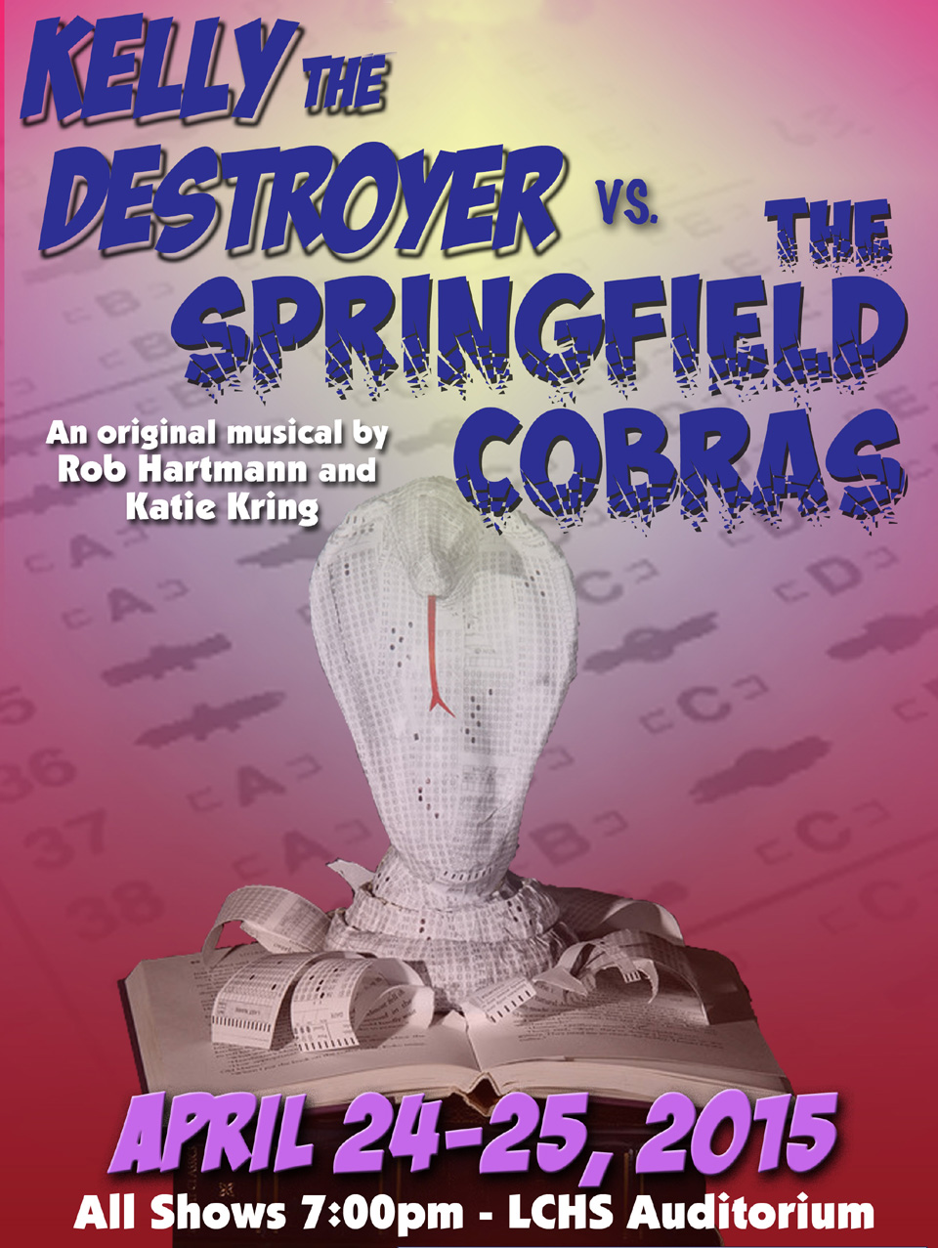

WWW.TIGERDRAMA.COM
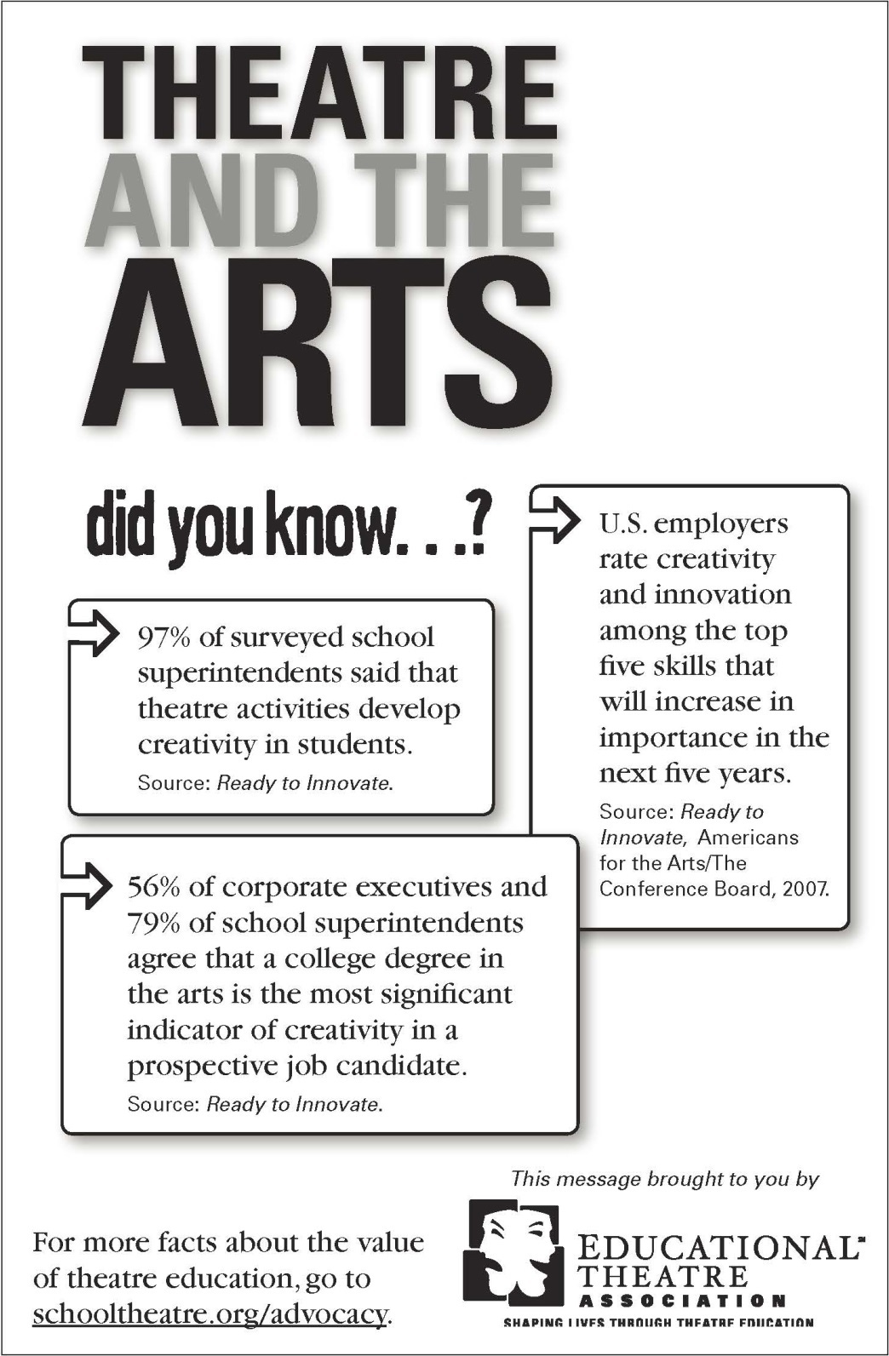
REVISIT OUR PAST SEASONS AT www.tigerdrama.com

 | 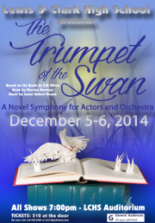 | 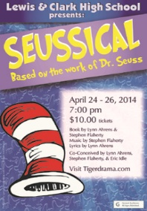 | 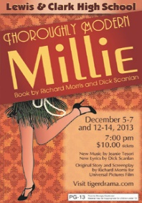
 | 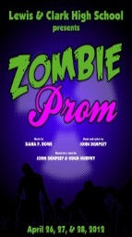 | 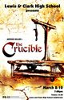 | 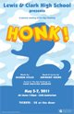
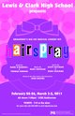 | 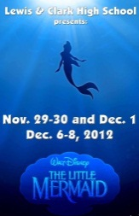 | 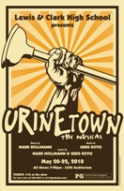 | 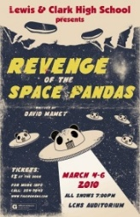
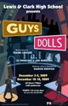 |  | 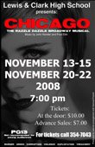 | 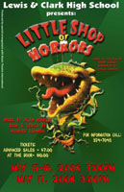

LEWIS & CLARK

TIGER DRAMA

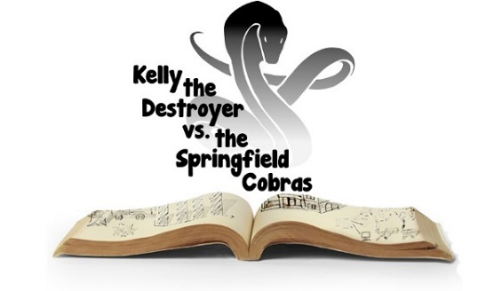
Book, Music and Lyrics by Rob Hartmann & Katie Kring

Greg Pschirrer - Director & Choreographer
Caryssa Murphy - Musical Director
Suzanne Maguire - Production Coordinator

Brie Cole | Anna Maguire
Kezia Rhodes  Brittany Mendoza-Peña | Sarah Wier  Melina Palomba

with

Dominick Betts | Jillian Burgess | Kira J Cinq-Mars
Olivia Davis | James Elkin | Tailer Englehart Grotte
Chloe Forsberg | Cori Gillis | Ray Gillis
Bailey Heppler | Ilan Hernandez | CaraLee Howe
Beth Lambert | Julian Lee | Emma Lyons
Jackson McMurray | Emily Ovens | Will Petro
Katlynn Souers | Victoria Eden Whiteaker

Orchestration and Tracks | Poster & Projection Art | Costumer
Rob Hartmann | Anna Maguire | Lisa Caryl Vukas
Program Design | Hannah Puppet Design | Snake Puppets Design
Theresa Meyer | Anna Maguire | Bailey Heppler
Additional Choreography | Scene Design/Construction | Headshots
Angela Pierson  Brittany Mendoza-Peña | Stagecraft Class | Scott Martinez & Richard Maguire
.
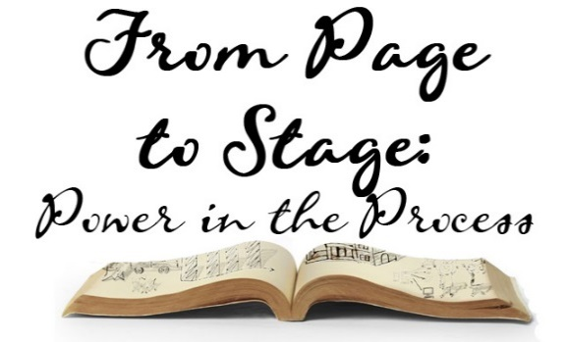
OUR 2014-2015 SEASON
FROM PAGE TO STAGE:
POWER IN THE PROCESS

Our 2014-2015 Tiger Drama Season theme is ‘From Page to Stage: Power in the Process’. From a Shakespeare classic to a brand new 21st century musical, this season demonstrates what students and audiences can learn from the powerful process of bringing words to life and collaborating in the creative development of a production. In November, we collaborated with our AP literature classes to study and present Shakespeare’s A Midsummer Night’s Dream. Along with our symphonic band and orchestra, we were the first high school in the country to bring the E.B. White classic children’s novel The Trumpet of the Swan to life in December. We are exploring how a theme can be presented thematically through subject matter, but also through physical, visual, and scenic elements as well. Having students be part of creating this season has been exhilarating and daunting but a challenge that has forced us all to realize the vast amount of skills and talents necessary to create such complex stories. Time management, collaboration, creative and critical thinking, perseverance and resilience are just a few of the skills taught, practiced and refined in the process of bringing each of the shows this season to life.

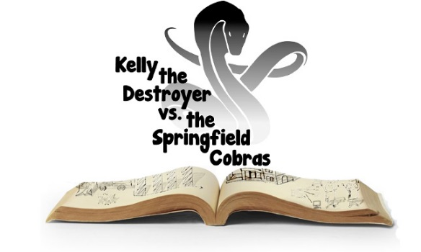
KELLY THE DESTROYR
VS. THE
SPRINGFIELD COBRAS

Perhaps the most exciting aspect of following the process of material going from page to stage is the creation of a 21st century, world premiere musical: Kelly the Destroyer vs. the Springfield Cobras. This production has been created by composers Rob Hartmann and Katie Kring working with students in our Musical Theatre class. Covering 21st century themes of increased standardized testing, academic pressures and student individuality within mounting educational uniformity, Tiger Drama’s production of Kelly may open the door for discussion, dialogue and opportunities for other schools throughout the country to share.

Work on this show began last spring when students auditioned knowing nothing more than the title of the show. Over the summer, Rob and Katie worked to create a structure/framework for the production. This fall, the collaboration began. Students have been involved in forming their own characters, tracing themes in education and offering input on the complex issues they confront as they prepare for life beyond high school.

SPECIAL THANKS

Marilyn & Robert Summerford | Richard Maguire
Scott Martinez | Jim Swoboda
Musical BFA students of  Wright State University | Troy Nickerson &  Stage Left Theater
Musical Theatre Dramaturgy students at the University of Portsmouth (UK) | STAGE parents including Lisa Forsberg, Kim Hernandez & Selma Rhodes
Bill DeCaro | Mark Wilder

2015 TIGER DRAMA DATES
May 11-12 Auditions - Closing Night
June 2-3 Dress Rehearsals - Closing Night
June 4 Closing Night
June 8 5th Ave Awards – Seattle

Stay updated on everything that is going on at LC!

Visit
www.lctigers.com
FOR MORE INFORMATION ABOUT KELLY THE DESTROYER VS. THE SPRINGFIELD COBRAS, PLEASE CHECK OUT THE WEBSITE AT WWW.KELLYTHEDESTROYER.COM TO SEE HOW THE PROCESS EVOLVED

Become a Tiger
Drama Patron

If you have the means and the heart to share, please consider being a financial sponsor of LC Tiger Drama. Examples of what donations sponsor:

- $50 helps sponsor guest teachers who are experts in their fields (stage make-up, stage combat, lighting design, etc.).
- $100 helps us add scripts to the theatre library, a valuable classroom resource.
- $250 helps us maintain or replace our stagecraft supplies (tools, appliances, lumber, etc.)
- $500 helps us maintain or replace lighting equipment.
- $1,000 helps us pay for the rights for a play.
- $2,500 helps us pay for the rights, scripts, and music for a musical.
- $5,000 helps us maintain or replace parts of our flies system (curtains, rigging, etc.).

Interested in participating or becoming a Tiger Drama Patron?
Email tigerstagegroup@gmail.com
CREW

Hair & Makeup...........................................................Harley Haberman
Costumes.....................................................Halaina Halsted, Miranda ……………….Anthony-Miller, Isabella Weiand, Pauletta Caryl
Lights.........................................................James Hogstad, Liam Schaaf
Projection Design………………………………….…Emma Lyons
Projections/Backstage....................................................IsabellaWeiand
Sound...................................................................................Scott Martinez Hannah Snake Puppet Design/Construction............Anna Maguire
“Snakes in a Crate” Design & Construction..............Bailey Heppler
Additional Choreography ………..Brittany Mendoza-Pena, Angela Pierson
Ushers……………………….Anna Budke, Sam Dunlap, Celeste Gray, Hannah Kinsella, Anissa Martinez, Eric Rorholm, Claire Woodard

ABOUT THE PLAYWRIGHTS

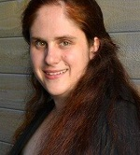
Katie Kring is a baker, artist, and writer-of-musicals, based in Springfield, MO. She received her MFA in Musical Theatre Writing at New York University’s Tisch School of the Arts and her BFA in Performing Arts Technology the University of Michigan in Ann Arbor. Previous collaborations with Rob Hartmann include FARMER’S MARKET: THE MUSICAL and two commissioned works for the Monterey Bay Aquarium. When she’s not writing, she runs a successful baking company, KatieMade, which specializes in artisan breads, gourmet confections, and all manner of other things fantastical and delicious. She also enjoys spending time with her pet ducks and her beagle, Challah.

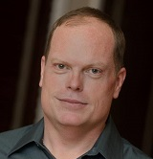
Rob Hartmann is on the faculty of the Graduate Musical Theater Program at New York University’s Tisch School of the Arts, where he received his MFA. He has a BFA in Musical Theater performance from the University of Arizona in Tucson. His work has been produced across the country, including in New York, Los Angeles, Chicago, Seattle, and other cities. Some of his musicals include MACABARET, written with Scott Keys, which has had over two dozen productions; and VANISHING POINT, written with Scott Keys and Liv Cummins which most recently won Best Small Musical for its Baltimore production. Rob is also an orchestrator and arranger, whose work has been heard in Carnegie Hall and Avery Fisher Hall in New York.
WHO’S WHO IN THE CAST

 | Dominick Betts (Class of 2015) is excited to originate Woodchuck. Favorite roles include Horton in Seussical and Emmett in Legally Blonde. Other favorite include Into the Woods and Trumpet of the Swan. He is honored to have worked with Pschirrer and Maguire who have changed his life. He would like to thank Jesus for everything.
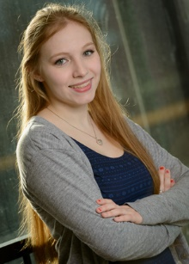 | Jillian Burgess (Class of 2015) Jillian is ecstatic to be a part of such an incredible process. She has been involved in a large amount of LC productions for the past three years. She's excited to continue her last few months at LC with such an incredible group of kids. She's attending WWU in the fall.
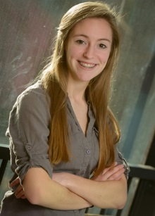 | Kira J Cinq-Mars (Class if 2016) is excited to be a part of this production! She has been involved in Tiger Drama since her Freshman year through classes and crew. She enjoys track, cross country, and dance in her free time. She would like to thank Mr. Pschirrer and Mrs. Maguire for this opportunity.
 | Brie Cole (Class of 2015) is ecstatic to have the opportunity to be in her final Tiger Drama production. She feels prepared to enter collegiate musical theatre next fall, as Mr. Pschirrer, Mrs. Maguire, Ben Bentler, her incredibly supportive parents, and others who have helped along the way have given her the tools to succeed. Thank you for the magic & joy!
WHO’S WHO IN THE CAST

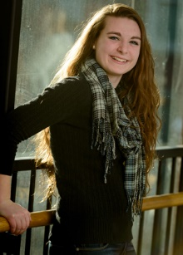 | Olivia Davis (Class of 2016) is a varsity debater and has crewed for multiple LC shows. In her spare time she loves to hike, sing, write, read, and spend time on Netflix. She plans to attend college where she hopes to continue involvement with musical theatre and debate. She dedicates her performance to her wonderful family & friends.
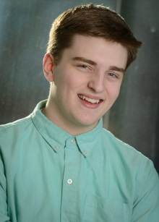 | James Elkin (Class of 2015) is extremely grateful to take part in his last show at LC. He dedicates his performance to his Mother Linda and Father Chad for supporting him throughout his journey, as a child and young adult. After a short 4 years with his classmates he's ready to go out with a bang and is excited to graduate with his class.
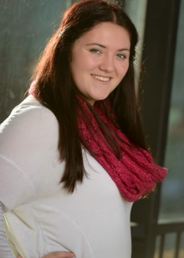 | Tailer Englehart-Grotte (Class of 2016) is excited to be in her second Tiger Drama production after A Midsummer Night’s Dream. She has been in 3 Theater Arts for Children including I Never Saw Another Butterfly & Bye Bye Birdie. She thanks her parents for the support and her grandparents for giving her rides for every rehearsal.
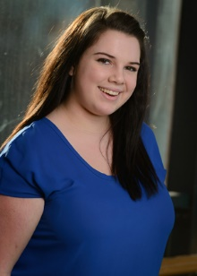 | Chloe Forsberg (Class of 2016) is excited to be in her second LC production! She recently stage managed Lewis and Clark's Into the Woods. She thanks Pschirrer and Maguire for the opportunities they have given her, and her parents for giving her rides even though she should have her driver’s license.
WHO’S WHO IN THE CAST

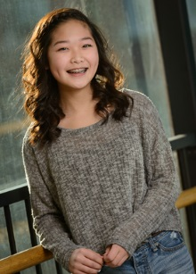 | Cori Gillis (Class of 2015) is excited to be working on her fourth production at LC. She has been in A Midsummer Night’s Dream and has worked crew on Seussical and Into the Woods. She would like to thank Pschirrer, Maguire, Katie, and Rob for this opportunity!
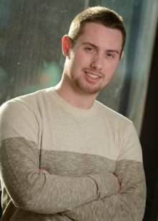 | Ray Gillis (Class of 2015) Ray is thrilled to be a part of this exciting new production! This is his 4th show with LC's Tiger Drama department, with roles in "The Little Mermaid, In the Heights, and Seussical. He was last seen as the mayor in Seussical the Musical! He hopes you enjoy the last show he will be a part of at LC!
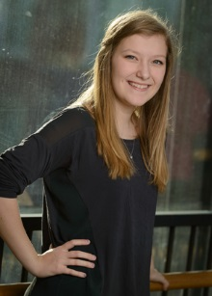 | Bailey Heppler (Class of 2017) has been involved in theatre for six years both on and offstage. Her most recent roles include Puck (Midsummer) and Enid Hoopes (Legally Blonde). She has also designed props for LC and area productions. She would like to thank Pschirrer, Maguire, Rob, and Katie for this incredible opportunity.
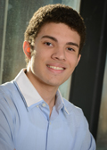 | Ilan Hernandez (Class of 2016) is thrilled to participate in this premiere musical and the amazing learning process! LC appearances this year include Into the Woods, A Midsummer Night’s Dream. His LC theatre education is shaping his life and future plans. He is very thankful for the camaraderie of his graduating cast mates.
WHO’S WHO IN THE CAST

 | CaraLee Howe (Class of 2016) is so excited to be a part of her 5th LC show! She has been seen previously in Into the Woods, Thoroughly Modern Millie, and others. She is a part of National Honor Society and is active in community theatre. She dedicates her performance to her big brother Aaron who has always been her biggest fan!
 | Beth Lambert (Class of 2016) is thrilled to be a part of this production! She previously appeared in LC’s Thoroughly Modern Millie (Lucille) and Into the Woods (Lucinda). She is thankful to be a part of this amazing opportunity and thanks her family and friends for always being there for her.
 | Julian Lee (Class of 2016) Previous LC appearances include Into the Woods, A Midsummer Night's Dream, and Noises Off. She would like to thank Mrs. Maguire and Mr. Pschirrer for all the time they've put into helping her grow and learn as an artist as well as a person, as well as Katie and Rob for this opportunity!
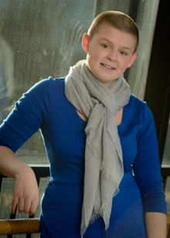 | Emma Lyons (Class of 2016) is so excited to be performing in this novel production. You can usually find Emma backstage and she enjoys designing lights. You could have seen Emma's lighting design this year in Into The Woods. She performed last year in Seussical!
WHO’S WHO IN THE CAST

 | Anna Maguire (Class of 2015) is grateful she spent high school with this department, and she is so happy to have this experience as her last. Anna will major in Film Animation at the University of Utah next year. She dedicates her performance to everyone who has played a part in her spectacular 4-year adventure.
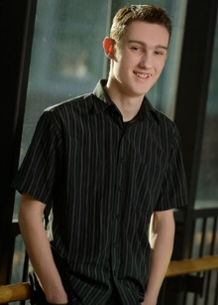 | Jackson McMurray (Class of 2015) performed in LC’s Thoroughly Modern Millie and A Midsummer Night's Dream (Lysander). Jackson also ran the turntable during the recent Into the Woods. He thanks all of LC drama for threatening him if he didn't audition for Millie two years ago.
 | Brittany Mendoza-Peña (Class of 2016) is honored to be a part of such a unique process like Kelly! She has appeared in LC’s Into the Woods (Red), Thoroughly Modern Millie and In the Heights (Nina). She thanks Pschirrer and Maguire for their continual support and the cast for all their hard work!
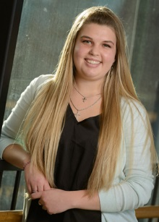 | Emily Ovens (Class of 2016) is excited to be debuting in her first LC production! She began dancing at the age of 2 at the Dance Center of Spokane until the 8th grade and then moved to Sandra's Studio of Dance. Darin Hilderbrand is her voice teacher. She dedicates this performance to her friends and family.
WHO’S WHO IN THE CAST

 | Melina Palomba (Class of 2015) is honored to be premiering Vi in her twelfth show in the Lewis and Clark theatre department. Previous shows include Seussical (Bird Girl), Thoroughly Modern Millie (Muzzy Van Hossmere), and Into the Woods (Witch). She dedicates her performance to her friends and family.
 | Will Petro (Class of 2016) is excited to be in his eighth show at LC. Previous appearances include Noises Off, Trumpet of the Swan, Into the Woods (Prince Charming/Wolf) and Seussical (Cat in The Hat). In his free time he enjoys making music and studying languages.
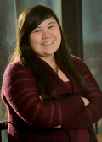 | Kezia Rhodes (Class of 2015) is extremely excited and grateful to be performing in her sixth LC musical. In her free time she enjoys reading, chilling with her friends, and making her cats chase lasers. She has previously been seen in Into the Woods and Seussical at LC. She plans on attending George Fox University in the fall.
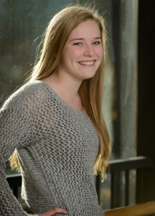 | Katlynn Souers (Class of 2016) is thrilled to be in her second LC production after appearing as a Who in Seussical the Musical. She has also been a part of Opening and Closing Night showcases and has been on crew The Dining Room and Into the Woods. She dedicates her performance to her loving family and truly supportive friends.
WHO’S WHO IN THE CAST

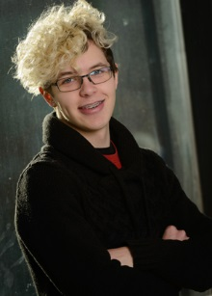 | Victoria Whiteaker (Class of 2015) has been involved in Tiger Drama for all four years, and has been on crew for four shows as well as in the cast of Midsummer Night’s Dream. She would like to thank her mother and grandparents for their continued support.
 | Sarah Wier (Class of 2015) can't believe she's already in her last LC show! Recently, she appeared in Into the Woods, Trumpet of the Swan, and Legally Blonde at Civic. Sarah would like to thank Pschirrer and Maguire for all they've taught her, and her wonderful family, friends, and boyfriend for all their love and support.
ABOUT THE COSTUMER

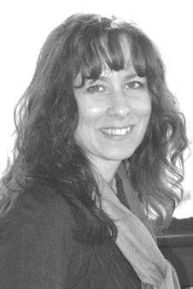 | Lisa Caryl (Costumer) has costumed shows for Spokane Civic Theatre, Interplayers, Spokane Children's Theatre, and Actors Repertory Theatre. She works as a costume designer with North by Northwest Productions. Lisa is thrilled to be working with this amazing program.
WHO’S WHO IN THE CREW

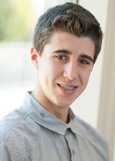 | James Hogstad (Class of 2016) is glad to crew his first show at LC. James has performed in the productions of Thoroughly Modern Millie and A Midsummer Night’s Dream and looks forward to learning more as a Stagecraft student next year.
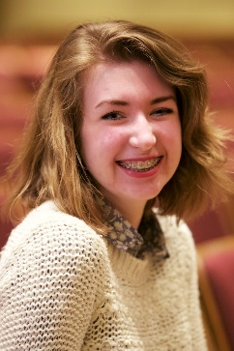 | Isabella Weiand (Class of 2016) has crewed multiple productions at LC and was recently recognized by the International Thespian Festival as a National Qualifier with her costume construction design. She will attend the National Thespian Festival in Lincoln, NE this June with 15 other LC students.
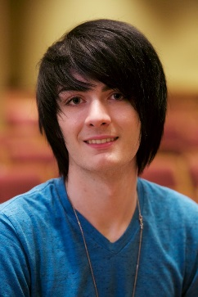 | Harley Haberman (Class of 2016)has assisted with Hair and Makeup for many LC shows and designed and built Rapunzel’s 7 feet of hair for Into the Woods. Harley’s work has led to local professional work on videos and film.
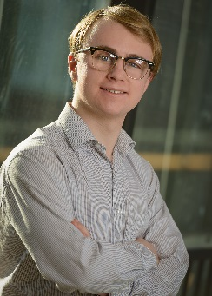 | Liam Schaaf (Class of 2015) has appeared in LC’s Thoroughly Modern Millie, Noises Off, Seussical, and A Midsummer Night's Dream. He is on the LC Knowledge Bowl team and thanks Pschirrer and Maguire for teaching him everything he knows about theatre, and for allowing him to put that knowledge to use.

CAST

The “Humans”
KELLY.....................................................................................Brie Cole
RIKKI.............................................................................Anna Maguire
WOODCHUCK..........................................................Dominick Betts
MOUSE.................................................................................Cori Gillis
BEE...................................................................................Emma Lyons
KICK......................................................................................Ray Gillis
DARZEE........................................................Tailer Englehart-Grotte
ZEN.................................................................................Beth Lambert
ADDIE..........................................................................Chloe Forsberg
SHINN................................................................................James Elkin
The “Cobras”
SAVANNAH...............................................Brittany Mendoza-Pena
CORAL..................................................................................Julian Lee
VI................................................................................Melina Palomba
BOOM.........................................................................Ilan Hernandez
COPPER................................................................................Will Petro
WHIP.............................................................................Jillian Burgess
KRAITLYN...............................................................Kira J Cinq-Mars
INDIGO........................................................................Bailey Heppler
ANA.................................................................................Olivia Davis
SCARLET.........................................................................Emily Ovens
FEATHER....................................................................Katlynn Souers
PRAIRIE.......................................................................CaraLee Howe
The Adults
HANNAH..........................................................................Sarah Wier
PRINCIPAL MUNGUS................................................Kezia Rhodes
MARSH.................................................................Jackson McMurray
HAWKINS..................................................Victoria Eden Whiteaker
SONG LIST

TIME AND PLACE
Cotesville Magnet High School, present day.

Act One
- Higher All
- Fall In Line Hannah and Students
- Help Me Help You Mungus and Hannah (with Boom and Copper)
- Kelly the Destroyer Kelly and Company
- The Scientific Method Kelly and Rikki
- Tough Love Savannah, Vi, Coral, Kelly
- Not The End of the World Kelly, Addie
- So Darn Cute Mouse and the Mammals
- My Otter Mouse and Company
- Fall In Line (Reprise) Addie, Savannah and Students
- Fight Or Flight Kelly and Company

Act Two
- Springfield Woodchuck and Company
- Mouse in A Maze Shinn, Woodchuck and Company
- Shed Your Skin Hannah and Company
- The Lady and the Legend Hawkins and Company
- Kelly the Destroyer (Reprise) Kelly and Company
- Come Back to Bite Ya Hannah and Company
- Turn the Page All

PLOT SYNOPSIS
Act 1
The show opens on Rikki and the other students at Cotesville Magnet High School early on a Saturday morning. They are stressed, tired, and back at school for yet another mandatory pre-testing day. Simultaneously, we meet Shinn, a college junior studying engineering, and his younger sister Kelly, who has just moved in with him after their parents were forced to take jobs in another country. Her parents have left her a present: a t-shirt labeled “Kelly the Destroyer.” Shinn informs her that, despite it being a Saturday, she’s supposed to be at school.
Kelly arrives at the school as the students are filing in for a mandatory assembly and meets Rikki’s friends, Woodchuck and Mouse. Principal Mungus introduces a new educational consultant, Hannah. She announces a new testing and study protocol for the school, the Springfield System, and a new mascot, the Cotesville Cobras. She introduces the students who participated in her pilot study group: NAGA (Natural Athletes, Gifted Academics) and leads and encourages all students to join the program.
Headed to her first class, Kelly meets more of Rikki’s friends, including Mouse’s bandmates Bee, Kick, and Addie, as well as Zen and Darzee, who are organizing a River Otter Awareness Dance. In class, she meets Hawkins, a literature and mythology teacher who has been forced to teach chemistry. The NAGA students have disturbingly perfect recall of the periodic table and Kelly rails against their unthinking rote memorization. Mungus is panicked by the high-stakes testing regime. She fears being scape-goated for poor student performance. Hannah offers her help in exchange for control over the school, and Mungus falls under her spell.
Kelly tells Shinn about the weird school and students. He reminds her that she has a record of causing trouble at school in the past. Kelly tells him that the school is extremely hot and he gives her advice about how to fix the air conditioning. That night, Kelly and Rikki break into the school and go down to the basement to find the A/C. When they do, they realize that it’s not broken at all, but that someone has set it to 95 degrees. So they fix the problem. The next day, the students are abuzz with news of Kelly and Rikki’s exploits. Hannah bursts in and insists everyone go outside to the track, where it’s warm. Hannah declares that everyone will be doing sprints. Darzee pulls a muscle and the NAGAs gang up on her and tell her how much of a failure she is. After the sprinting, Hannah announces that a new test will take place tomorrow. Addie has a breakdown from the stress of it all, and Kelly comforts her with the knowledge that failure is not the worst thing that can happen.
The next evening, the students set up for the River Otter Awareness Dance, but Mouse and her band are in a tizzy because Addie hasn’t been seen all day. Zen bursts in with a very weird discovery… a human-sized skin (like a shed snake skin) that looks disturbingly like Addie. The band goes on without Addie, even though Mouse is very hurt that her best friend would bail on her. Suddenly, the NAGAs burst in, with Addie, who is now one of them. They create chaos and stop the dance. The students are crushed by the strange behavior of their friends, but Kelly has a theory – the temperature, the mascot, the name NAGA, the skin – Hannah is turning them all into brainwashed cobras! It seems far-fetched, but it’s the only explanation. The students resolve to fight as Hannah prepares her cobras for battle.
Act 2
The humans try to figure out what they’re up against with Hannah’s Springfield System. Woodchuck remembers that there was a cobra outbreak in Springfield Missouri in 1953. It must be connected! Seen in flashback, Woodchuck tells the story of how a young boy went into a pet shop to buy a fish. After the fish died and he was denied a refund, he released a freshly delivered package on the porch — all the way from India! Several days later, some women out gardening discover a snake in their yard and kill it with a hoe. The people of Springfield think that’s hilarious…until cobras start turning up all over town. To solve their cobra problem, they get an ice cream truck, and drive around town playing Indian snake charmer music to try to lure the cobras out of hiding. By the end of the scare, they’d caught and killed 12 snakes.
The students realize they need proof of what Hannah’s up to, and there’s only one place to find it: in her office. They split up and sneak through the school. Finally, Kelly, Rikki, and Mouse make it to the office and get the evidence, but as they’re making a run for the door, Mouse is captured. Rikki takes the new evidence to Mr. Marsh. When she gets to his office and shows him the evidence, he tells her that he’s very disappointed in her and she realizes that he’s now a cobra too. Three of the cobras appear and Rikki is captured as well.
Kelly and the few remaining humans are trying to figure out their next move when Hannah and the cobras appear. Just when the humans are about to be sucked under the snake mind-control, Kelly snaps out of it, and pulls the others to safety, but as they run, Woodchuck is lost.
Now thoroughly demoralized and mourning the loss of their friends, the humans are considering making one last stand when Hawkins appears. He tells them a legend about a girl who found a village overrun with snakes, and all the villagers were begging her to save them. They didn’t need a hero – just a person – and she was a person. Kelly hears all of the cobrafied students begging her to save them. As Hawkins goes to leave, he hands Kelly a comic book that Rikki had been drawing in class – “Kelly the Destroyer”. Kelly reads about her amazing exploits through Rikki’s eyes, and draws the strength to go back and fight for her best friend.
The humans go to the cobras under the ruse of wanting to join them. But when it’s time to actually start transforming, Kick runs and Kelly uses the distraction to find and grab Rikki. Kelly’s grasp breaks the spell on Rikki, and she’s restored to herself. The students each run to their friends and set them free. Hannah, when she discovers this has happened, turns into a giant, enraged cobra. Just when Giant Cobra Hannah is about to kill all of the students, Principal Mungus comes in and defeats Hannah once and for all.
The school is back to normal, but now all of the students have to rebuild their relationships and lives. As they pick up and head home, we see that one cobra, Vi, has not been restored, and is off to another school to start a study group…

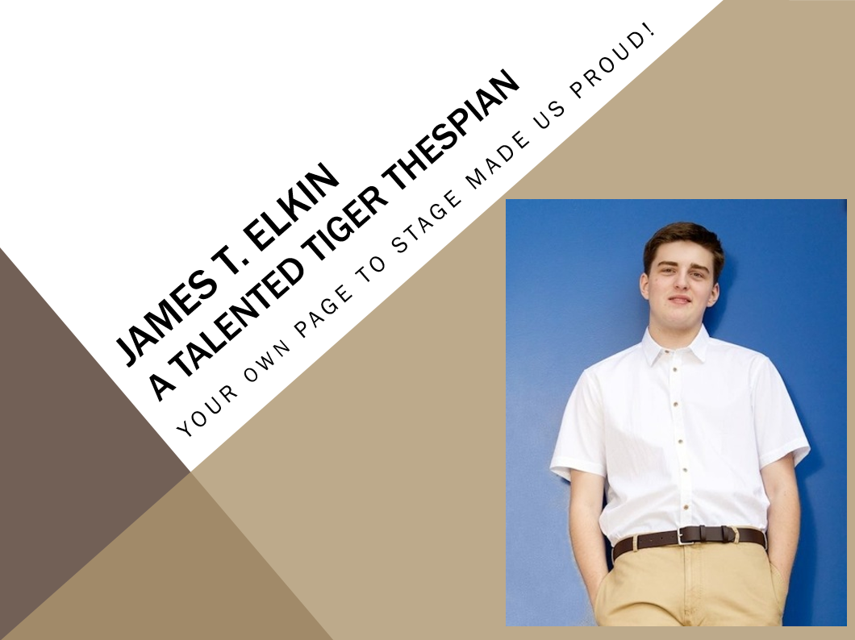

Anna - From your first role at Mullan Road Elementary to now, your last role at LC, your talents continue to amaze us and make us so proud! We can't wait to see the art yet to come from your new adventures in college!
We love you - your family of fans

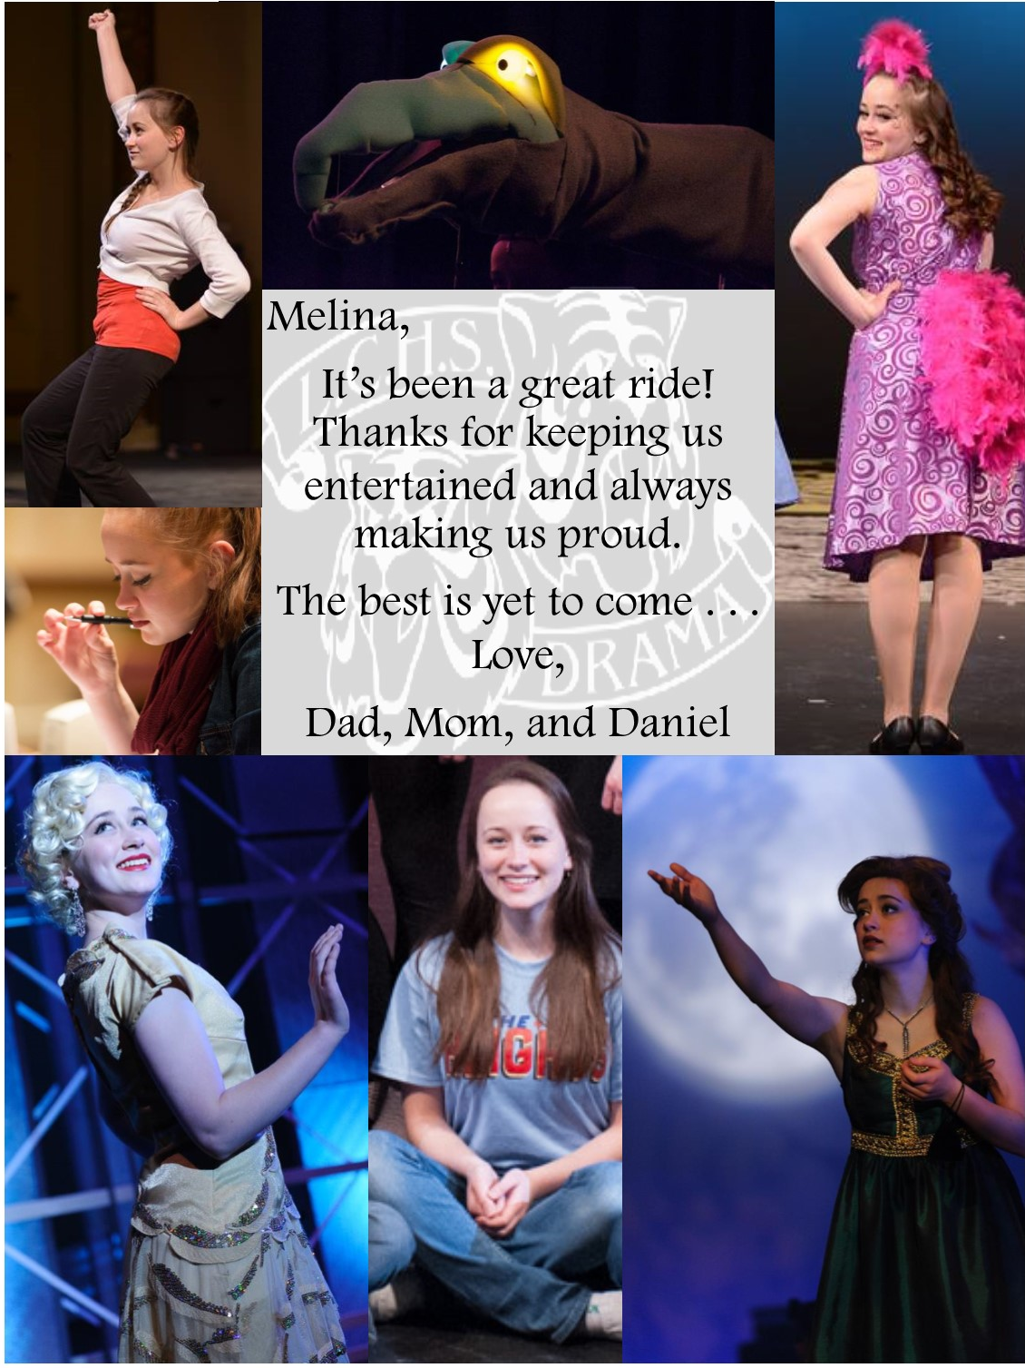

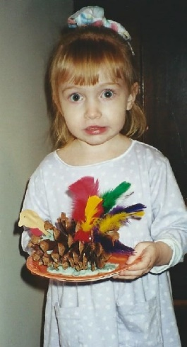
Our Little Sprouter has blossomed into a bright and beautiful young woman. You make us so proud! We know you are going to do great things!

Love Mom, Dad, Emilie, Sara Kate, Mamoo, Uncle Shawn, Aunt Joy and the rest of your family and friends.

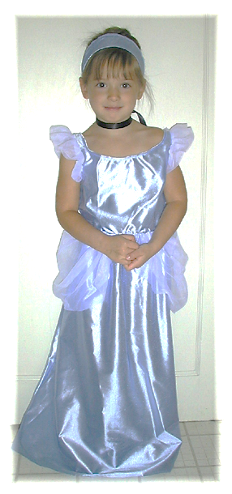
Brie,

You've worked hard bringing forth your talent while fulfilling your dreams in musical theater. And we've come to embrace so many of your friends and their parents along the way too!

Uncle Craig and Aunt Doria, Uncle Don and Aunt Cheryl, and your mom and dad are so very proud of your accomplishments over the past four years academically, and with LC Tiger Drama.

What a great ride! Now, you're on the final stretch of your senior year...finish strong...
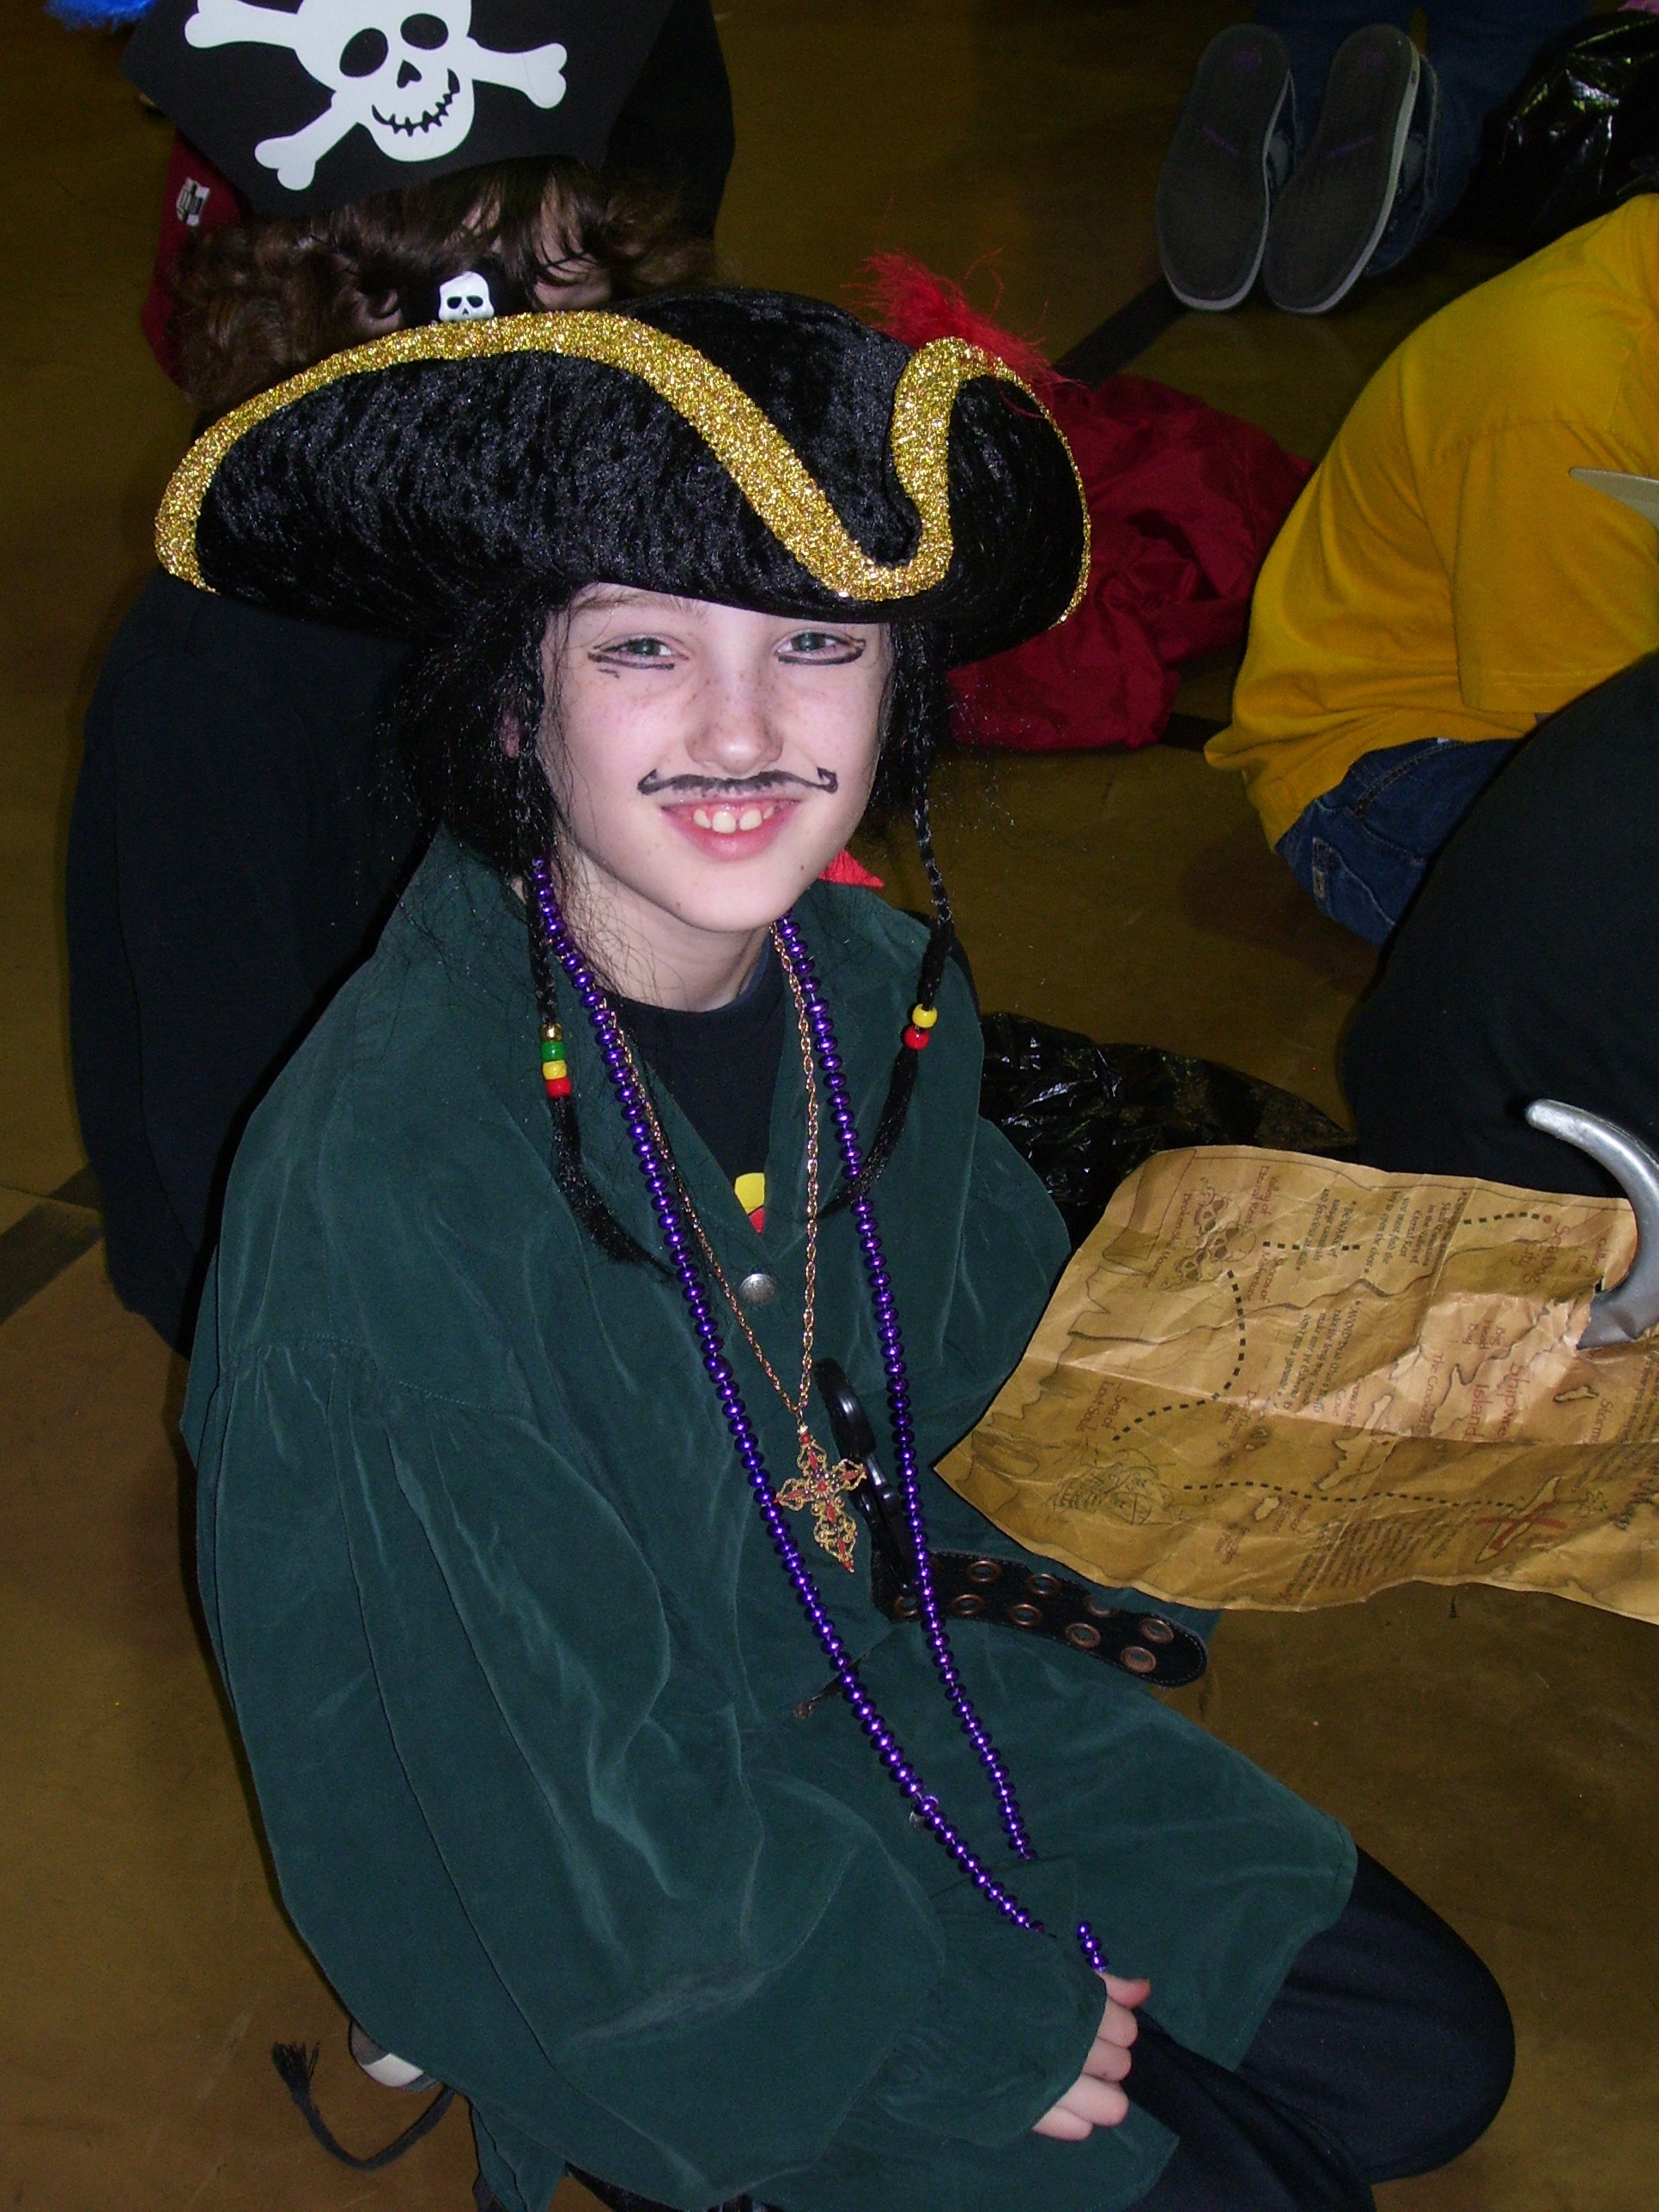

Jackson McMurray

We love you and are so proud of you!!

Dad, Mom & Adeline

Ilan…

AP – SAT – SBAC?!
You’re already a success in our book! No test scores necessary!

So proud of you,
Dad, Mom, Isaiah
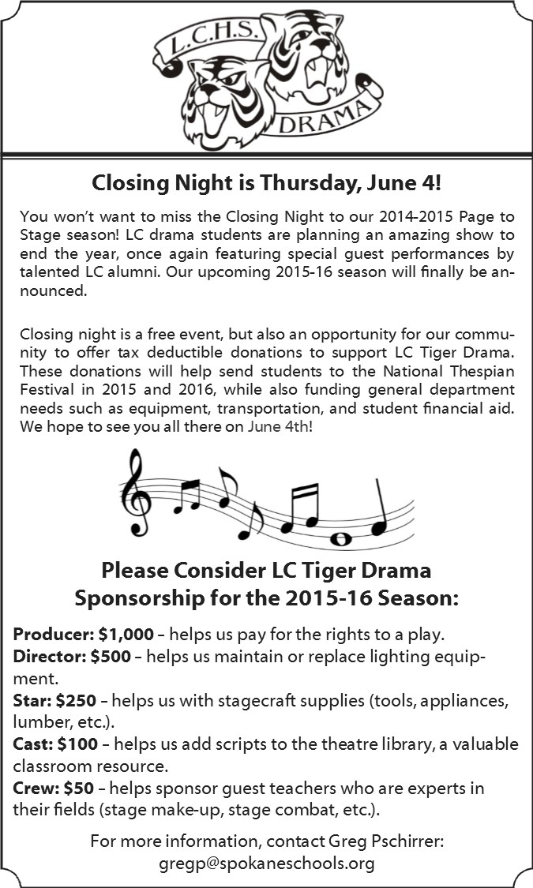
ABOUT THE DIRECTORS

Greg Pschirrer (Director/Choreographer) is enjoying his 12th season as Drama Director where he has helmed over 35 productions. As a performer, he appeared in: The 25th Annual Putnam County Spelling Bee, Forever Plaid, Cats, and West Side Story. He holds a BA in History (Gonzaga) and an MA in Theatre Production (CWU). This production is dedicated to his parents for instilling a love of storytelling and all the love, support, and guidance over the years.
Suzanne Maguire (Production Coordinator) holds a Bachelor’s degree and Secondary Education Certification in Speech Communication and Theatre from Northern Arizona University. She is grateful to Mr. Pschirrer for inviting her to work with Tiger Drama. For another season of support and participation, she is ever grateful for her wonderful husband, Richard and kids (Brennen, Anna & Elliott)!
Caryssa Murphy (Musical Director) is excited to once again be partnering with Tiger Drama for a musical. As the choir director at LC, she has most recently conducted Thoroughly Modern Millie and In the Heights, as well as music directed The Little Mermaid Jr and Seussical Jr. She can also be seen around town in various productions through Spokane Civic Theater and the Modern Theater. She would thanks her husband for his continuing support for her love of the arts.

